Assignment .1

Q.1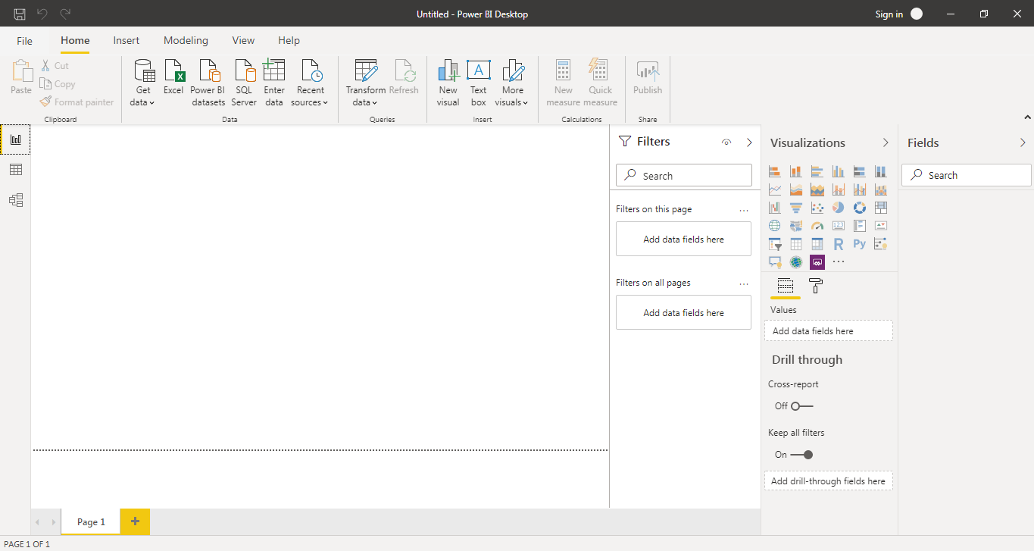

Q.2.1

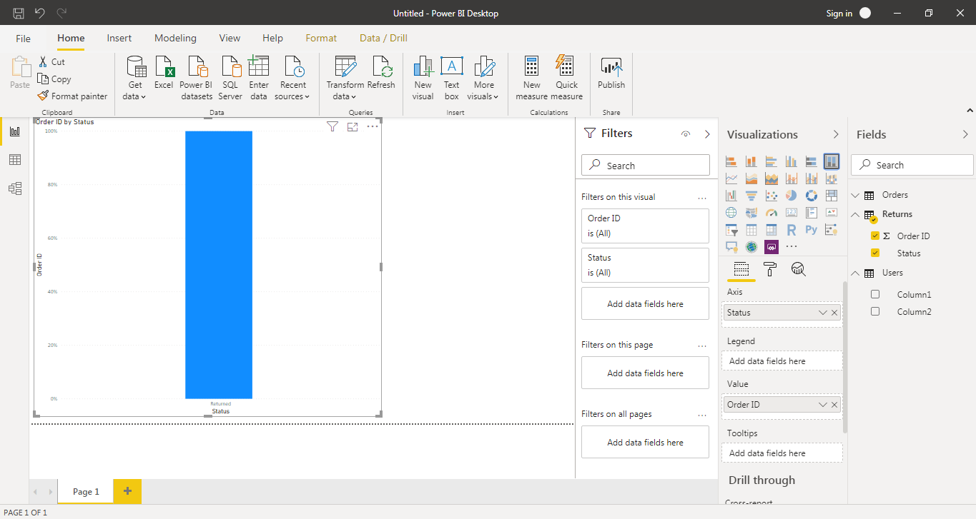

Q.2.2

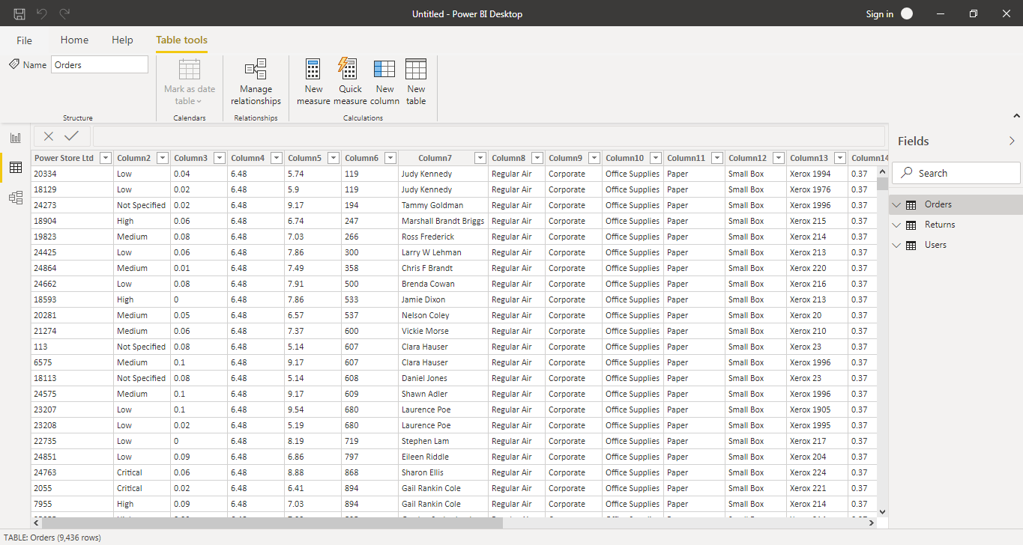

Q.2.3

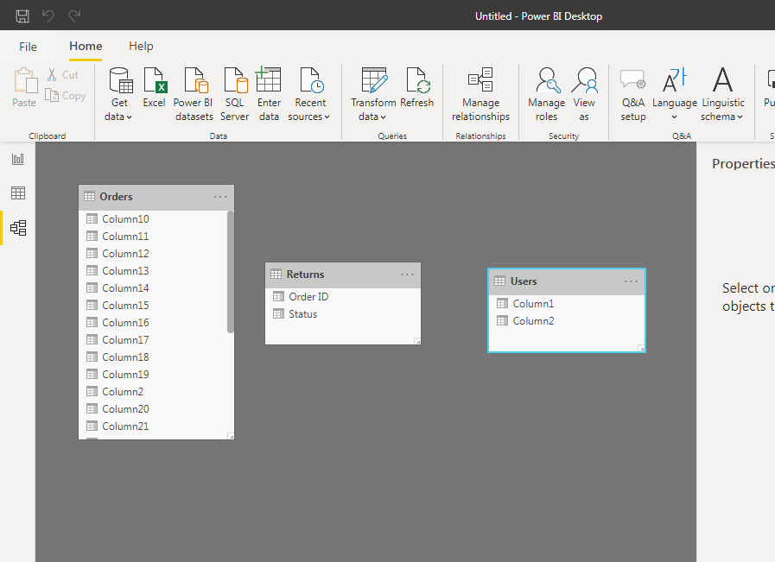

Q2.4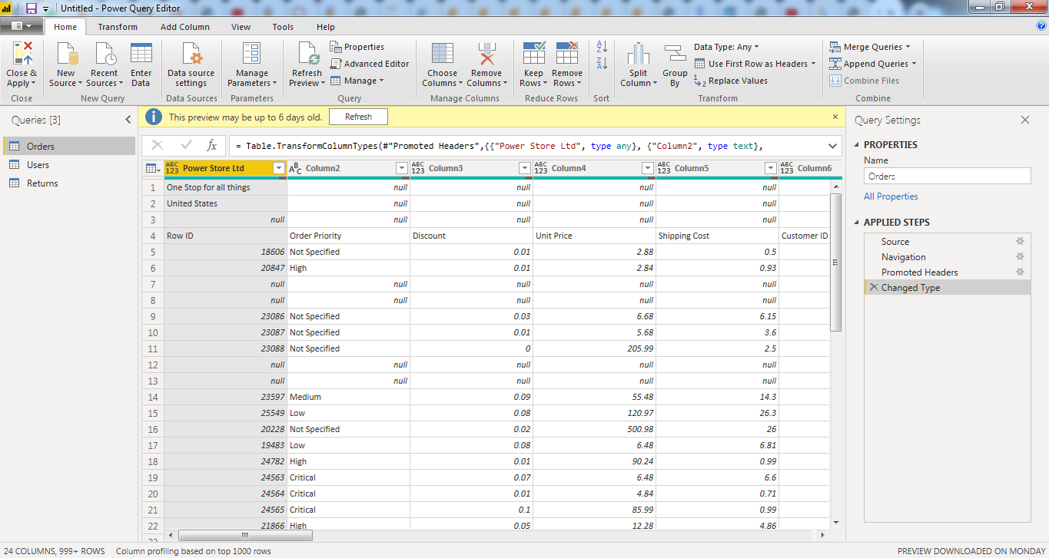

Q.2.5

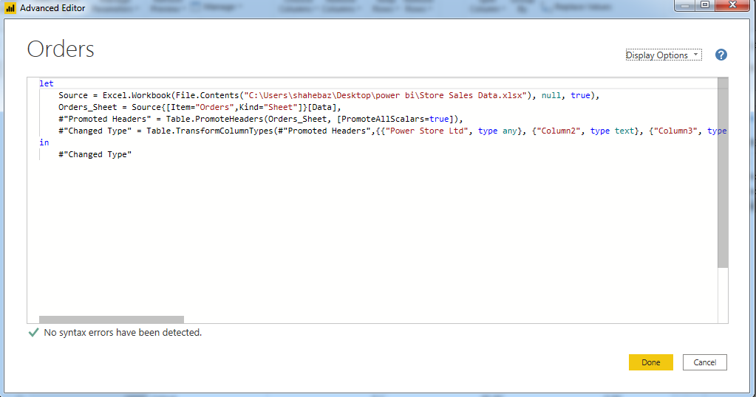

Q3.1

Power BI desktop is free.

Q.3.2

Power BI Pro is for 660 rupees per month

Q3.3

Power BI premium is for 3,30,190 rupees for month per dedicated cloud compute and storage resource with annual subscription.